A Comparative Study of ORC Working Fluids Performance in Ultra Low-Grade Waste Heat Recovery from Data Centres
Sai Sudharshan Ravi^{a*}, Daniel Alexander Florez Orregoª, Shivom Sharmaª, Francois Merchalª
ªÉcole polytechnique fédérale de Lausanne
sai.ravi@epfl.ch
Abstract
The increasing growth of data centers worldwide has ushered in an era of unprecedented data processing and storage capabilities. As data centers play a pivotal role in the ever-increasing use of cloud computing, social media, and online services in general, their energy consumption continues to rise, accounting up to 1-1.13% of the global electricity demand. Data centers produce low-grade heat. The energy-intensive operations of data centers have spurred a growing interest in waste heat recovery technologies as a means to enhance energy efficiency by usage of this waste heat for electricity generation and district heating. This study examines the waste heat potential of a 5MW data center that primarily employs liquid chip-level cooling to convert waste heat into electricity using an organic Rankine cycle (ORC). By comparing the performances of different working fluids such as R245fa (dry), R134a (wet) and R1234zeE (isentropic) in ORC systems optimized to have the lowest operating cost, this study attempts to understand the operating conditions that maximize the energy savings and improve the Energy Reuse Efficiency (ERE) indicator in datacenters, aiming to reduce the environmental impact.
Keywords: Data Centres, ORC System, Working fluids, System Modelling.
  - Introduction and background
In an era dominated by the unprecedented proliferation of digital data; data centers have emerged as the linchpin of our global information ecosystem. However, the digital renaissance comes with a daunting challenge—the efficient management of the substantial waste heat produced by data centers. The EU has set a goal for the year 2030 in which it aims to reduce the greenhouse gas (GHG) emissions by 40%¹. A large amount of this could be reduced by reducing the energy consumption of the district heating (DH) systems. Waste heat from the data centres offers the opportunity to reduce the DH load and thereby reducing the overall energy consumption for DH, as discussed by Oro et al (2019)². The heat available from the data centers would still be available during summer when there is not much need for direct heating applications. This heat could then be used to produce electricity by the use of an organic Rankine cycle (ORC). Figure 1 (a) shows a simple schematic diagram of how the waste heat from the data centre can be used to produce work using an ORC. In this study we intend to analyze different working fluids, which are selected for the case of data centers using a prescreening tool suggested in Kermani et. al (2018)³, in an ORC superstructure that operates optimally between 5 different pressure levels by optimizing the overall operating cost of the system. The choice of working fluid becomes critical to the ORC’s efficiency, as discussed by Herath et. al (2020)⁴. The working fluids are largely classified as dry, wet and isentropic fluids. Figure 1 (b), (c) and (d), show the TS diagram of these fluids along with a simple ORC with superheating for dry, wet and isentropic fluids correspondingly.

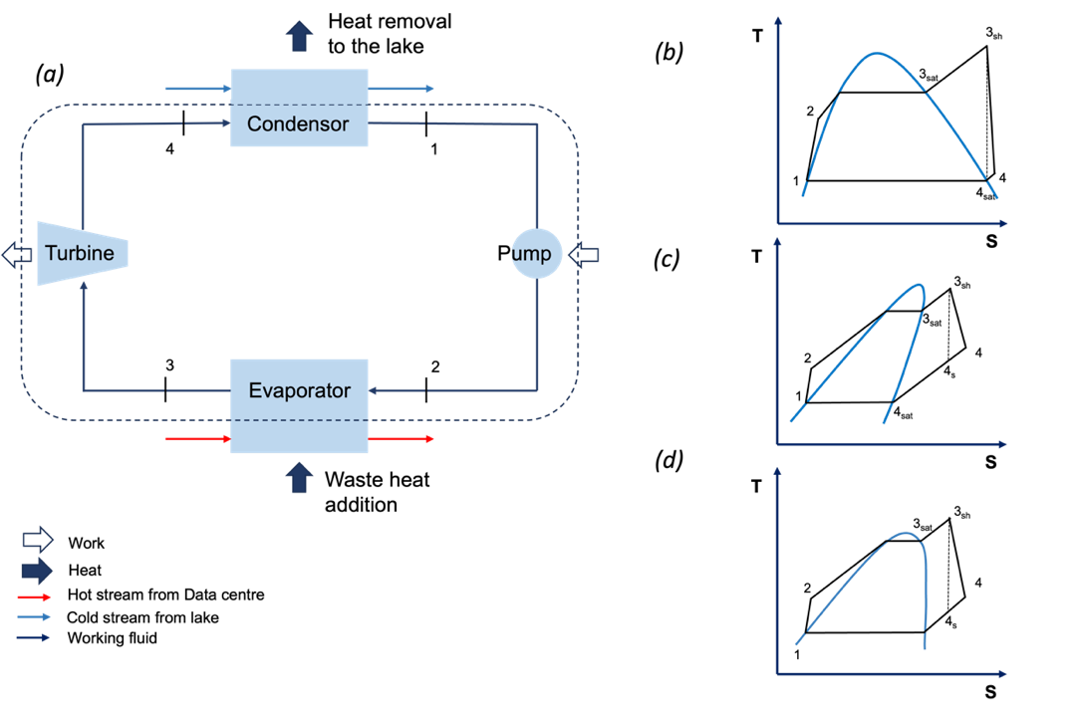

Figure 1 (a) A schematic diagram of simple Organic Rankine Cycle (b) TS diagram for a dry working fluid (c) TS diagram for a wet working fluid (d) TS diagram for an isentropic working fluid

  - Problem Formulation
In this study, we focus on harnessing the potential of R134a (wet), R245fa (dry), and R1234zeE (isentropic) within the context of ultra-low heat recovery applications, specifically in conjunction with a data center's waste heat. Our primary objective is to leverage these three distinct refrigerants, each optimized for heat integration using OSMOSE, a decision support tool, to maximize energy recovery from the data center, maintained at a steady temperature of 85 ºC. Complementing this, we utilize lake water as our cold source, with an assumed inlet temperature of 15ºC. This temperature differential between the heat source and the cold source forms the crux of our integrated composite curve, allowing us to efficiently extract and convert waste heat into electricity which is then either to partially power the data centre again or integrated to the grid as shown in Figure 2. By focusing on this temperature range, our research seeks to better understand factors that affect ultra-low heat recovery and promote sustainable energy practices within data center operations, as discussed by Montalya et al (2023)⁵. Some of the key fluid properties of the different fluids chosen for this study are summarised in Table 1

Table 1: Summary of working fluids chosen for ORC. Bell et. al (2014) ⁶

 | R134a | R245fa | R1234zeE
Type | Wet | Dry | Isentropic
Boiling Point  (⁰C) | -26.3 | 14.72 | -19.27
Critical Temperature  (⁰C) | 101.06 | 153.86 | 109.37
Critical Pressure  (bar) | 40.59 | 36.51 | 36.36
Global Warming Potential (GWP100) | 3830 | 3380 | -
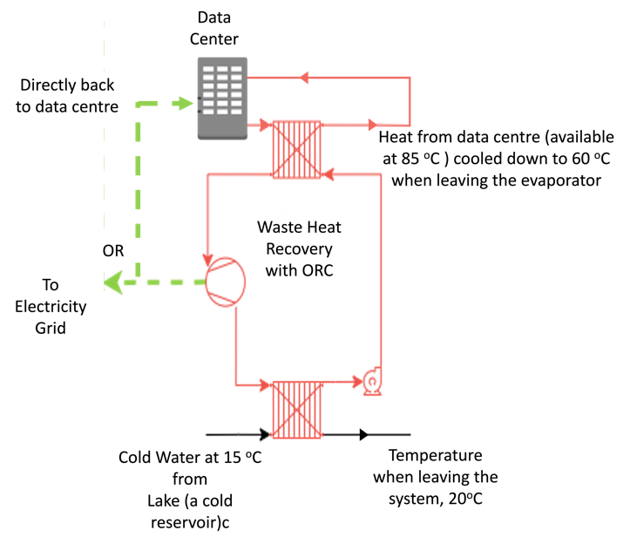
Figure 2 A simplified schematic of the overall process system showing heat removal from the data centre and electricity generation
  - Results and Discussion
By calculating the amount of electricity produced with each of these working fluids, we were able to calculate the efficiency of electricity production in each case. Assuming that the data centre has a power usage effectiveness of 1.58 and a system heat recovery potential of 0.96, we estimated that the heat available to be converted to actual work in the system was only about 3038 kW. The electricity produced and the efficiency is tabulated in Table 2 below. The efficiencies as calculated here for an ultra-low grade waste heat recovery scenario for the different working fluids, seems to also conform with the findings of Vittorini et al (2019)⁷. and Dai et. al(2009) ⁸
Table 2: Efficiency of ORC system with different working fluids

 | R134a | R245fa | R1234zeE
Heat available from system (kW) | 3038 | 3038 | 3038
Temperature of hot source (ºC) | 85 | 85 | 85
Temperature of cold sink (ºC) | 15 | 15 | 15
Electricity produced (kW) | 268.3 | 270.8 | 267.5
Efficiency (%) | 8.83 | 8.91 | 8.8

2.1 Thermal Efficiencies comparison
Furthermore, the efficiencies of these fluids, as delineated in Figure 2 (a), provide critical insights into the thermodynamic characteristics of each working fluid, thereby aiding in the selection of the most suitable medium for waste heat recovery. In the context of waste heat recovery for data centres, thermal efficiency and electric power generation are paramount. A high thermal efficiency signifies the effective utilization of waste heat, reducing operational costs and environmental impact. This is particularly vital for data centres with their energy-intensive operations. The electric power generated by the Organic Rankine Cycle (ORC) system represents a tangible output that can offset electricity consumption within data centres, enhancing their Power Usage Effectiveness (PUE), sustainability and reducing their reliance on conventional power sources, like discussed in Lei et.al (2020)⁹. In this regard, optimizing the thermal efficiency of ORC systems holds significant promise for the efficient and eco-friendly operation of data centres and of the three fluids considered in this study, R245fa like mentioned before, seems to have the most electricity generation for a given amount of heat supplied between these temperature limits.

2.2 Integrated Composite Curves
Integrated composite curves provide a graphical representation of heat exchange profiles in energy systems, revealing temperature pinch points and aiding in optimization. In the context of Organic Rankine Cycles (ORCs) operating between a waste heat source at 85 °C and a cold stream at 20 °C, the integrated composite curves, as depicted in Figure 2 (b), (c), and (d), serve as vital tools for optimizing energy recovery systems. These curves offer a comprehensive visual representation of heat exchange dynamics, enabling the identification of temperature pinch points and facilitating the assessment of energy utilization. Particularly, in the comparison of three distinct working fluids R245fa, R1234zeE, and R134a, it is evident, as illustrated in Figure 2 (b), that R245fa yields the highest power output, underscoring its better performance in this specific application.
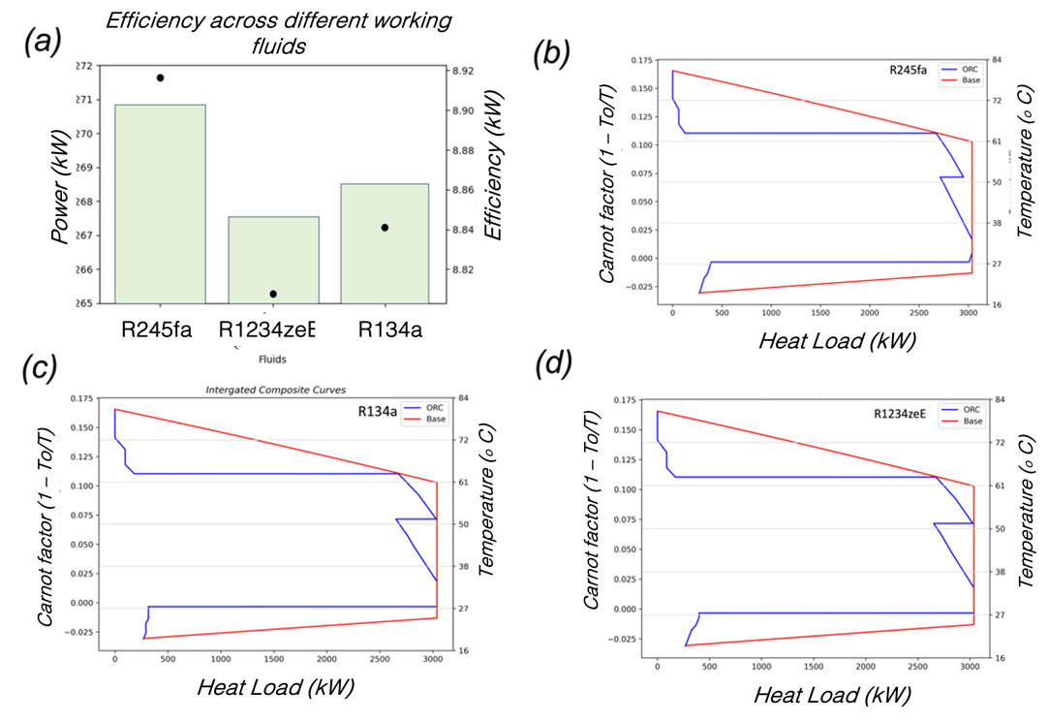

Figure 2: (a) Thermal efficiencies of the ORCs, when using these fluids. Integrated Composite Curves of a (b) R245fa (dry), (c) R134a (wet) and (d) R1234zeE (isentropic) working fluids with in the same temperature bounds

  - Conclusions
In summary, the investigation of three distinct working fluids in the context of waste heat recovery from data centers using Organic Rankine Cycles has revealed their comparative performance. Despite variations in efficiency, these fluids demonstrate nearly equivalent overall efficacy, affording the opportunity to consider other critical factors in the selection process. Such factors encompass environmental impact like the GWP100, specifically in the event of a leakage, as well as the optimization of the system with regard to objective functions extending beyond operational expenses. This study serves as a catalyst for forthcoming research endeavours in the realm of waste heat recovery, advocating a comprehensive approach to decision-making and the exploration of diverse avenues for advancing the sustainability of data center operations. Future research directions may encompass a more profound exploration of the long-term environmental repercussions, system reliability, and multi-objective optimization techniques, contributing to the refinement of working fluid selection and its implementation in waste heat recovery systems.
References
1. Reducing carbon emissions: EU targets and policies | News | European Parliament. https://www.europarl.europa.eu/news/en/headlines/society/20180305STO99003/reducing-carbon-emissions-eu-targets-and-policies (2018).
2. Oro, E., Taddeo, P. & Salom, J. Waste heat recovery from urban air cooled data centres to increase energy efficiency of district heating networks. Sustainable cities and society 45, 522–542 (2019).
3. Kermani, M., Wallerand, A. S., Kantor, I. D. & Maréchal, F. Generic superstructure synthesis of organic Rankine cycles for waste heat recovery in industrial processes. Applied energy 212, 1203–1225 (2018).
4. Herath, H. M. D. P., Wijewardane, M. A., Ranasinghe, R. A. C. P. & Jayasekera, J. G. A. S. Working fluid selection of Organic Rankine Cycles. Energy Reports 6, 680–686 (2020).
5. Montagud-Montalvá, C., Navarro-Peris, E., Gómez-Navarro, T., Masip-Sanchis, X. & Prades-Gil, C. Recovery of waste heat from data centres for decarbonisation of university campuses in a Mediterranean climate. Energy Conversion and Management 290, 117212 (2023).
6. Bell, I. H., Wronski, J., Quoilin, S. & Lemort, V. Pure and Pseudo-pure Fluid Thermophysical Property Evaluation and the Open-Source Thermophysical Property Library CoolProp. Industrial & Engineering Chemistry Research 53, 2498–2508 (2014).
7. Vittorini, D., Cipollone, R. & Carapellucci, R. Enhanced performances of ORC-based units for low grade waste heat recovery via evaporator layout optimization. Energy Conversion and Management 197, 111874 (2019).
8. Dai, Y., Wang, J. & Gao, L. Parametric optimization and comparative study of organic Rankine cycle (ORC) for low grade waste heat recovery. Energy Conversion and Management 50, 576–582 (2009).
9. Lei, N. & Masanet, E. Statistical analysis for predicting location-specific data center PUE and its improvement potential. Energy 201, 117556 (2020).

